Connecting to the Akamai Flash Network an encoder that does not support authentication
Any given third party encoder will usually have problems connecting to Akamai, since the Adobe Flash authentication is Adobe proprietary, and the Akamai authentication mechanism is proprietary as well.
Our Flash network supports two types of authentication:
- Native Adobe Flash authentication, used by Flash Media Encoder
- Our own challenge-response authentication
May be the encoder developer can reverse-engineer the adobe.dll file in FME and find out how it works, but chances are they just assume that you will have no authentication in your FMS to make things easier for them.
To solve this problem, I have written a small FMS application that will authenticate with the Akamai entry point and act as an authentication gateway for any no-authentication encoder.
This application waits for a stream publish from an encoder and republishes the stream in Akamai. It has proven to work with FMS 3.5.
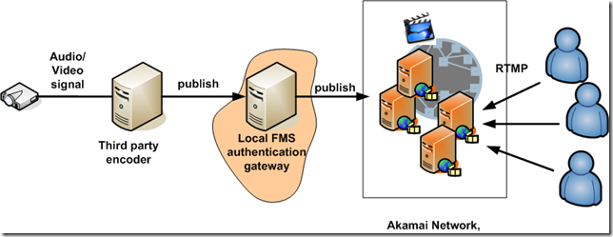

How to build the system
To make the whole system work, you will need a FMS server where to install the application.
First, download the code
- Unzip the code to your FMS applications folder
- Edit the file "config.asc" to enter the CPCode, password and Stream ID.
- Restart FMS
- Configure your encoder to connect to your FMS:
  - URL: rtmp://IP_OF_YOUR_FMS/eprepublish
  - Stream Name: the Akamai stream name
When you start the encoder, it will connect to the local FMS, which in turn, will connect to Akamai, authenticate, and publish the stream.

